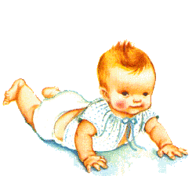
Baby Dedication
(for 12 months old and below)

When parents bring their children for dedication, they are signifying their faith in the Christian way of life. The act of dedication does not automatically make the children Christians. When the child comes of age, he will need to receive the Lord Jesus Christ as his Lord and Saviour. Baby Dedication is a point of beginning in which parents commit the children to God for His care in matters beyond human wisdom and understanding.

This public act signifies a partnership with the church to teach the children early to fear the Lord and to direct their minds to the Holy Scriptures. Parents take upon themselves the responsibility to lead their children to church, and to bring them into a personal relationship with Christ their Saviour.

INFORMATION FOR PARENTS
In Church of Praise, baby dedications are conducted in our cell groups at any time of the year. If you do not belong to any cell group we can assist and link you to the cell nearest your home.

------------------------------------------------------------------------------------------------------------------
(cut this out)
Baby Dedication
(for 12 months old and below)

Name of Father: Tel: (H) (O) (HP)

Name of Mother: Tel: (H) (O) (HP)

Address: S( )

Child’s full name: Sex: Male / Female

Date of Birth: Name of Hospital:

Cell Group: Preferred Date of Dedication:

Church of Praise, 5 Koek Road, #05-07 Cuppage Plaza S(228796) Tel: 63443500 Fax: 63443600
Email: admin@churchofpraise.org.sg Homepage: http://www.churchofpraise.org.sg

CHURCH OF PRAISE is in fellowship with the Assemblies of God worldwide

